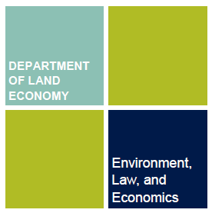 | VISITING SCHOLAR APPLICATION FORM

Please complete your details below and return to: visitors@landecon.cam.ac.uk

When you return the form, please also attach the following:

- A copy of your current CV (Resume)
- Your Research Proposal (no more than one side of A4 paper)
- Confirmation of support from your Cambridge Host/Supervisor (an email is acceptable)
- Confirmation of funding
- A scanned copy of the photo/details page of your current passport
- English language assessment certificate (if applicable)

Please make sure the information provided here is accurate and if applying from outside the UK please complete the medical insurance section.

First Name
Last Name
Date of Birth
Gender (Male/Female/Other or prefer not to say)
Title (Mr/Ms/Dr etc.)
Nationality
Passport Number
Residential Home Address
Please do not state your university department address as your home address
Email address
FOR OVERSEAS VISITORS ONLY:
Please provide details of medical insurance (or financial assurance) as to the payment of medical expenses (if required) during your visit
English Language Assessment (if applicable) e.g. TOEFL/IELTS or Cambridge Assessment Centre score
Description (Academic Researcher or PhD Student on placement)
Home Institution/Employer  (Note: This should not be listed as the Chinese Scholarship Council) | Name of Department/Institution:  Address:
Home Institution Supervisor/Head of Department (Note: This should not be listed as the Chinese Scholarship Council) | Name:  Position:  Email address:
Host/Supervisor at Department of Land Economy, University of Cambridge | Name:  Position:
Activities while visiting at Land Economy
e.g. Independent/Collaborative Research
Start date of visit
End date of visit
Total number of weeks/months
Hours of access to the Department | 20-30 hours per week
Confirmation of funding
E.g. China Sponsorship Council or Erasmus
Applicants must prove adequate funds to cover the cost of the bench fee (see webpage for details)

Please return this form to the LE Visiting Scholar Coordinator: visitors@landecon.cam.ac.uk

