The first fifty years
By Professor Ian Hodge
Ian Hodge is Professor of Rural Economy in the Department of Land Economy and Fellow of Hughes Hall. He was Head of Department between 2002-2011
In 2012 represents a major anniversary in the history of Land Economy; it is fifty years since the University of Cambridge approved the introduction of the Land Economy Tripos and the creation of a Department of Land Economy.

Antecedents

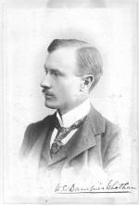
The origins of Land Economy in the University of Cambridge date back to teaching in Estate Management within the School of Agriculture. The idea behind this may be attributed to a Flysheet written by William Cecil Dampier (pictured) FRS, Senior Tutor at Trinity College, who in February 1917 advocated the creation of a ‘great School of Rural Economy in the University’. He saw the need for a professional education not only in agriculture and forestry that was already being taught, the Drapers Professorship and a course in agriculture had been established in 1899, but also in all the other departments of rural economy, including agricultural economics, law, surveying and architecture. While not fulfilling this ambition, a Readership in Estate Management was established in 1919. As explained by two Professors of Agriculture, Professors Wood, Drapers Professor, and Biffen, Professor of Agricultural Botany, in the Discussion of the proposal to establish the Readership[1], the matter had become urgent “because a large proportion of the students now in residence, many of them young men of the landlord class who have returned from the war, propose to take up the management of their own Estates, and are pressing for instruction in that subject”. For that reason, Estate Management had been included in the list of subjects in the examination for the ordinary degree in Agriculture, Estate Management and Forestry.
As has subsequently come to be familiar, the proposal was not without its critics. In the Discussion on the proposal, Dr Mayo offered strong opposition[2]. “He was sorry that the General Board of Studies had been influenced by the letter of two Agricultural Professors, who in their turn had been influenced by a proposal made in a very vague and informal way to the University. These were times when it was notorious that the very strictest economy was being daily advocated by the Press and others, and they were all perfectly aware what need there was for the utmost personal economy, and here they were asked to accept £500 of public money. .... He thought that every penny of the £500 would be utterly wasted”. He saw no need for Estate Management to be taught. For example “College estates were managed by the most competent men in the world, the College Bursars, who certainly did not require the assistance of a Reader in Estate Management.” He thought that “the whole proposal bordered on the ridiculous”. Again, with a clear sense of déjà vu, this was despite the fact that there was no cost to the University as the funds for the stipend were to be provided by the Board of Agriculture. It was also suggested that the subject was not a proper one for a University Readership. But others, more farsighted, argued that the University ought to be grateful and that there was a genuine need for such teaching. In Professor Wood's view "one of the chief factors that caused the agricultural troubles of the last thirty years was the fact that our landlords had not taken the trouble to learn the technique of managing their own estates". The relevant Grace was passed by Senate on 31 October 1919. A stipend of £500[3] per year was guaranteed for 5 years, and Col. Frank Braybrooke Smith CMG of Downing College was appointed to the post on a five year term from October 1920[4] . The Reader, was ex officio a member of the Board of Agricultural Studies, but also connected with the Special Board for Economics and Politics.
Earlier threads leading to the present Department lie in the endowment of the Lectureship in the History and Economics of Agriculture by Sir Walter Gilbey in 1896 and the Lectureship in Forestry funded by Sir Eustace Gurney's Benefaction in 1916, both lectureships have subsequently been transferred to Land Economy.
The next significant stage was the formation of a University Department. A Syndicate was appointed in 1938 to consider the establishment of a department for the purpose of teaching and practical work in Estate Management, urban as well as rural, in June 1938. The original intention had been that the Syndicate should report by the division of Michaelmas term 1939, but progress was interrupted by the War. Their Report was subsequently submitted in May 1945, and subsequently published in March 1946 following consultations on the programme of teaching and research that the proposed department should undertake. The need for surveyors and estate managers was recognised prior to the War, but it was felt that following the war the Nation would be more conscious of the importance of the proper management of land, and the post-war problems of the restoration and rebuilding of damaged property, the need for planning, the demand for housing, and the organisation of agriculture and forestry. As a subject, Estate Management was seen to be concerned with Agriculture, Architecture and Building, Engineering, Law, Economics Political Science, and Public Health, but that the Department should not be placed within any of the faculties specifically concerned with these subjects. The Syndicate recommended the creation of a Department of Estate Management, independent of any Faculty, under the direct supervision of General Board. It should be responsible for the control and development of both the teaching and the professional work in estate management within the University. There should thus be close relation between teaching and professional work, seen to be of great value in the teaching of students and in the giving of expert advice. The Department was to be funded through students fees, what funds could be secured from the Ministry of Agriculture and Fisheries, and the fees earned by the professional work through charges made to the University and Colleges. The recommendations of the Syndicate were approved in May 1946.
The development of courses in Estate Management was a matter for consideration by the newly formed Board of Estate Management and General Board reported on this in July 1947. This recommended teaching rural and urban estate management in two separate courses, but with common subjects in law, economics, history and valuation. Less familiar to contemporary expectations in Land Economy may be the common elements in surveying, building construction and public health and hygiene. The subjects would be taught over three years leading to the Certificate of Proficiency in Estate Management and the Ordinary BA degree. The subjects of examination for the third year are shown below:
THIRD YEAR
Rural Course | Urban Course
(1) English Law (III) | (1) English Law (III)
(2) Principles and Practice of Land Administration [II(a)] | (2) Principles and Practice of Land Administration [II(b)]
(3) Theory and Computation of Land Values [II(a)] | (3) Theory and Computation of Land Values [II(b)]
(4) Stock Husbandry | (4) Building Construction and Hygiene (III)
(5) Chemistry of Foods | (5) Theory and Practice of Town and Country Planning (II)
(6) Estate Forestry | (6) Surveying (III)
As simply explained in the Schedule to the Report “Each of the three examinations shall be held twice in each year, beginning (a) in the Easter Term on the Wednesday or, if the next day be Ascension Day, on the Tuesday next but two before the first day of General Admission in that term, and (b) on the first weekday of October”. The Report also recommended the establishment of a Diploma in Estate Management to be taken in one year by graduates in Estate Management. This would allow specialisation in some particular field of Estate Management.
In order to deliver these courses, it would be necessary to expand the staff in Estate Management and the Report recommended that the establishment of the Department, at that stage comprising three University Lectureships, should be increased by a further four University Lectureships, two University Demonstratorships and one Faculty Assistant Lectureship. It was proposed that the annual fees charged, currently at that time between £37. 16s and £31. 10s in the Department of Agriculture, should be raised to £47. 5s[5] for all examinations equal to those already charged by the Board of the Faculty of Fine Arts for courses leading to the Certificate of Proficiency in Architectural Studies. The Grace for the approval of the recommendations passed the Regent House on 2 August 1947.

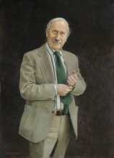
An appeal for funds in support of the development of estate management was initiated in 1948, led by the RICS and other professional bodies, and a Development Fund Committee was set up with the ultimate aim of securing £5,000 per annum for a minimum period of five to seven years. The publicity for the Fund would include a leaflet to be inserted in the Journals of the relevant professional bodies. But it was emphasised that “this leaflet will merely state that the Fund is being established. It will NOT ask for donations”[6]. This initiative was given the approval of the Council of the Senate and contributions were sought. Donald Denman (pictured) describes the progress with the appeal in his Half and Half Affair[7](pictured) and the initial funds secured supported the development of research into ‘land ownership economics’. However in the late summer of 1955, Ben Allsop, chairman of the appeal committee, reported that he had a potential donor, Harold Samuel, who had promised all the money needed. The details were resolved at a lunch in London at which Harold Samuel is quoted as asking what the sum was “that would stop his friend here, Ben Allsop, from pestering the City of London with his begging bowl”. Noël Dean, Head of Department, suggested the very substantial sum of £250,000 and this was agreed there and then.
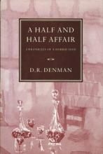
The endowment from Harold Samuel[8] to create the Estate Management Development Fund was a major boost to the Department. But the offer of the funds was a source of widespread debate within the University as to whether or not it should be accepted. As Donald Denman put it “The good souls wanted to say ‘Thank you’ and to do so at once but the narrow-minded, the ill-informed, the bigots, in the name of ‘right learning’ and the prudent use of resources and motivated by subconscious jealousy, abhorred the prospect of Estate Management receiving a benefaction of such unprecedented magnitude”[9]. Efforts by the Vice-Chancellor to encourage acceptance of the funds were seen as raising questions of ‘high public issue’, touching on ‘the ideals of the University itself’ against the threat of ‘domination by Money’[10]. Three months elapsed before the University promoted the Grace accepting the funds.
The acceptance of the benefaction established the Estate Management Development Fund to be held in trust for the furtherance in the University of research and study in estate management at the discretion of Managers. The initial gift of around £250,000 was equivalent to around £5.5 million in 2012 prices. The Fund was to be administered by Managers. Initially, these comprised Mr Noël Dean, Mr E.P. Weller, Mr T.C Thomas and Mr G.K. Allsop. In the longer term, the Managers were the Head of Department of Estate Management, the Chair of the Board of Estate Management, a person nominated by the General Board and two persons nominated by the Royal Institution of Chartered Surveyors. Subject to the discretion of the Managers, the objects of the Fund were to include the establishment of offices and posts, scholarships and research studentships and the provision of buildings and equipment. The arrangement gives considerable discretion to the Managers to regulate their own procedure and to determine what part of the Fund shall be available as income and what part shall be invested and used as capital.

The development of Land Economy
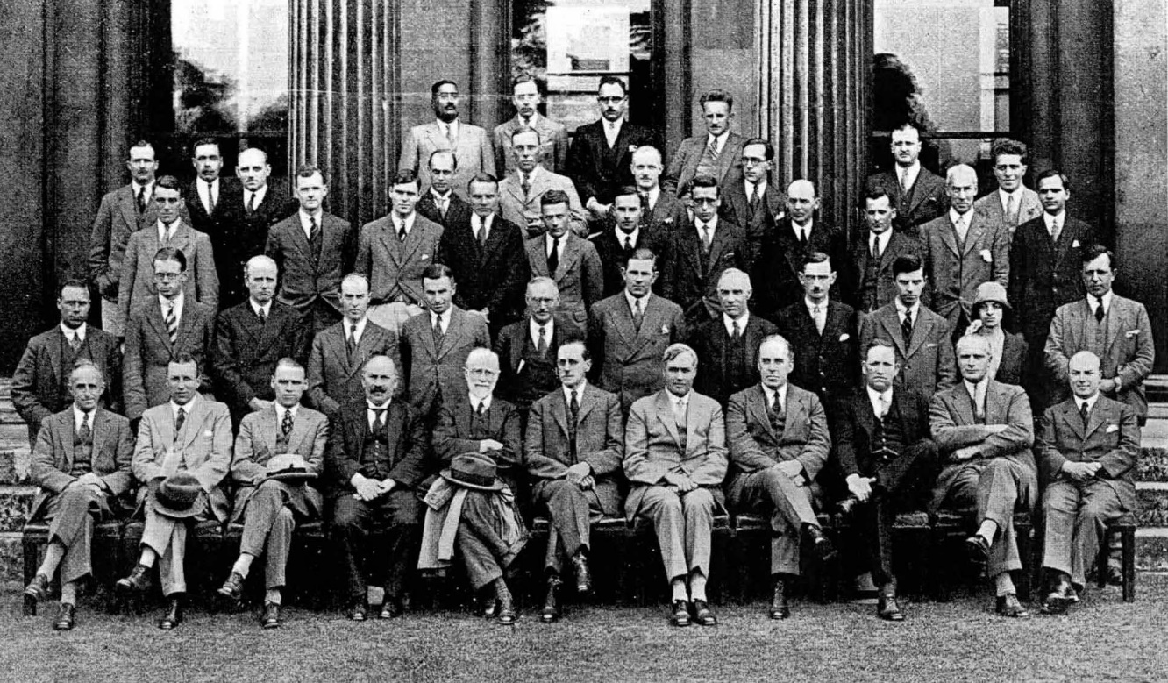
1929 (pictured above)
The creation of the Land Economy Department and Tripos dates from 1962. In anticipation of the retirement of Noël Dean, the Director of Estate Management, in 1961, the Board of Estate Management appointed a Committee in 1958 to consider the future of the Department of Estate Management. The Board concluded that the teaching and research functions should be separated from the professional work. The current arrangements were felt to be unsatisfactory, leading to ‘difficulties and misunderstandings’. The Board of Estate Management should be responsible solely for the teaching and research and there should be a separate office to carry out the professional advisory work with its own Director under the control of Financial Board. There should be a Head of Department of Estate Management who had a knowledge of economic, social and legal aspects of the tenure, use and development of land. The Board commented that they “believe that there are universal principles and problems of land tenure and land use, the way in which man organizes his environment, which in themselves provide an academic field for teaching and research”[11]. The Board wanted to see teaching developed along these lines, but that such a development should await the reconstitution of the Department and appointment of a new Head. These proposals were generally welcomed and, unusually, no remarks were made at the Discussion of the Report in November 1960. The Grace approving the recommendations passed Regent House in February 1961 and came into effect on 1 October 1961.
Attention then turned to the teaching programme and the establishment of a new Land Economy Tripos. The Board of Estate Management argued that the development of research in the Department of Estate management and corresponding advances in other Universities have shown that “the use, tenure, and development of land is an integrated subject of universal concern to human society and capable of being studied and taught in depth”[12]. The stage had been reached where the courses and examinations in estate management should be replaced by a course leading to an Honours Examination and proposed the establishment of a Land Economy Tripos consisting of one Part only and that it should be taken two years after obtaining honours in Part I of another Honours Examination. The Board offered a definition of Land Economy:
“Land economy is the study of the principles and policies of the use of land and land resources whether by political direction or by proprietary enterprise under legal restrictions. It is derived from a study of economics and law but does not lie wholly within the boundaries of either of these disciplines as academically understood. It is a logical academic advance from estate management; sufficient of a departure in content and principles to require a new title but not so far removed that it must be thought of as the introduction of an entirely new subject”
The approach towards the Tripos drew heavily on Donald Denman’s analysis of Proprietary Land Use and this was included as a key Paper. The Land Economy Tripos would consist of five compulsory Papers taken in the second year:
Paper 1. Land Law.
Paper 2. Social Land Use.
Paper 3 Proprietary Land Use.
Paper 4. Principles of Land Values.
Paper 5: Comparative Land Tenure.
In the first year, there would be a Preliminary Examination in Land Economy. The Board expected that Land Economy would normally be taken after a Part I in Economics, but the papers in the Preliminary Examination would be suitable for candidates who had obtained Honours in any Tripos.
Neither the Financial Board nor the General Board offered any objection to the recommendations in the report from the Board of Estate Management. At the same time, the General Board was conducting a review of Faculty and Departmental structure of the institutions in the University under their supervision and in their response to the report from the Board of Estate Management, they commented that they intended to propose “as a temporary measure only”, the constitution of a Department of Land Economy, independent of a Faculty in replacement of the Department of Estate Management and the replacement of the Board of Estate Management by a Board of Land Economy, with responsibilities for the new Tripos[13].
The University more widely was less unanimously sympathetic to the idea of a Land Economy Tripos. At the Discussion on 30 November 1961[14], Dr Ziman, having declared that he had “no authority at all to offer opinions on such a technical subject as Land Economy” nevertheless felt able to object that the subject was only being approached in its financial and legal aspects, that it was “too much concerned with money”. “It reads as a narrow professional training in the detailed administration of the financial aspects of Land Economy”, where, he said, he saw “almost no attempt to open the minds of students, to prepare to possible changes, to give them some idea of the variety of forms which social institutions have assumed and are assuming at other times and in other places”. Mr Laslett similarly felt that “professionalism, the sense of being here to train people for a career, for almost no purpose connected with the intellectual breadth of those we have to teach, is far too close to the surface of the Report”. But he also raised the spectre of a University being lured away from its ideals by external funds. He commented “It is a fact, not I think mentioned in the history of the study as outlined in the Report in front of us, that a very large sum of money was given to this University with the object, I suppose, of encouraging us to give precisely that status, that professional status, to the training of an auctioneer or an estate agent which it was felt the University of Cambridge could give to a study being pursued as part of its academic instruction.” He believed that “The University should give very grave second thoughts to the desirability of making this subject a Tripos at all”. In contrast, the Report was supported by Professors Boys Smith, Master of St John’s, and Kahn from the Faculty of Economics.
The Council of the Senate concluded in March 1962 that the arguments for and against establishing the Land Economy Tripos had been sufficiently canvassed and that the question should be put to the University for a decision. A Grace was therefore submitted at the Congregation on 24 March 1962. It was by all accounts a near run thing. Donald Denman tells the story in his Half and Half Affair[15]. When the Vice-Chancellor announced the General Board recommendation to Regent House, Peter Laslett responded with a ‘non-placet’ meaning that the decision would be subject to a vote by the whole of Regent House. There was vigorous campaigning to get signatures on a ‘placet’ flysheet. On the day of the vote, those assembled in Senate House voting ‘placet’ outnumbered the opposition and the Grace was approved as Grace 1 of 5 May 1962.
Following this, the General Board proposed on 25 July 1962 that the planned reorganisation should go ahead with the creation of the new Department of Land Economy and the introduction of the Land Economy Tripos. Final confirmation was attained when the Grace approving the General Board Report passed the Regent House at a Congregation on 3 November 1962. In consequence, the three year courses in rural and urban estate management and the Diploma in Estate Management were discontinued.
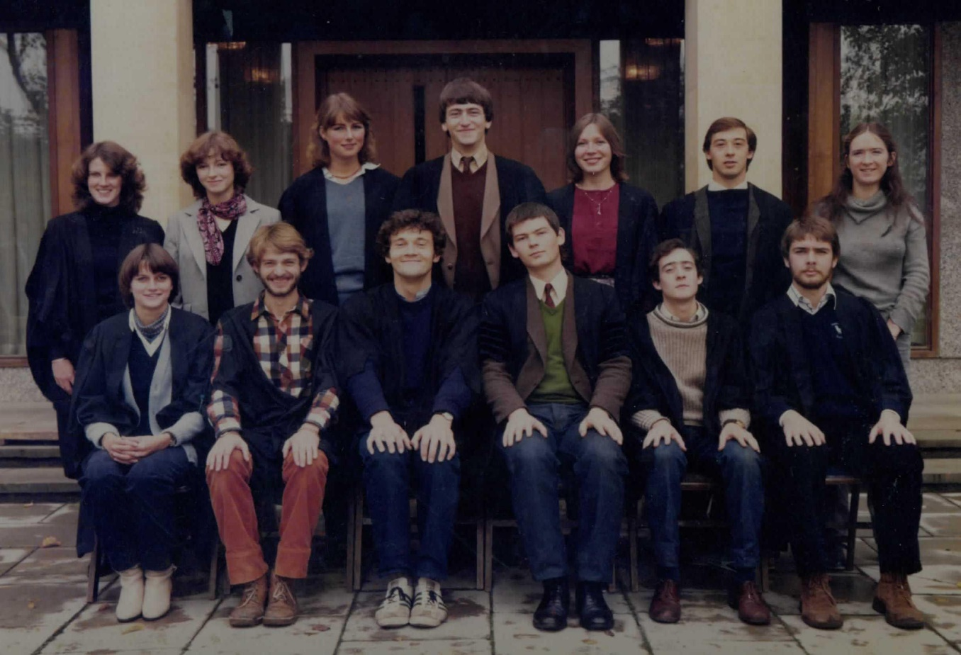
1981 (pictured above)
The composition of the Department was markedly changed in 1969 when members of the Farm Economics Branch were transferred to Land Economy on the closure of the School of Agriculture, creating the Agricultural Economics Unit and bringing in other University Lecturers to the Department. The Tripos was modified in consequence to reflect the broader range of interests across the Department’s staff. This does appear to have led to internal pressures and reflections on the direction to be taken by the Department. A glimpse one view of the state of things at that time is provided in a private letter in 1970 from Sir Edmund Leach, Provost of Kings, to Sir Eric Ashby, Master of Clare, who was being solicited to take on the role of Chair of the Board of Land Economy. Edmund Leach comments that he finds his membership of the Board to be a depressing experience and offers his view that “this is one of the weakest sub-units in the whole system and there are no doubt many people around who wonder why it should exist at all. .... a very unhappy ship which has no appeal either to College Tutors or to undergraduates, and the internal quarrels are formidable”. But more positively he observes that given the level of external funding “it doesn’t cost the University all that much”. On the other hand, “if anyone is to think seriously about the fundamentals of pollution and conservation in a University milieu, where better than a Department of Land Economy?”.
The early 1990s was another period when the status of the Department was being questioned. Declining student numbers and a concern that references to Land Economy in the media were more often found in the sporting pages than elsewhere, prompted reflections on the name of the Department. This came to a head with a ballot of all members of staff in 1994. A second ballot was conducted amongst students. The alternative names canvassed included ‘Property Economics and Law, ‘Land Planning and Management’, Environmental and Resource Management’ and ‘Land Resource Studies’. But while there were doubts about the extent to which the term ‘Land Economy’ conveyed the nature of the subject to prospective students or to the wider public, there was no consensus as to any of the alternatives and no change was made. On the whole, undergraduate students have tended tend to be content with the name, especially once they have graduated, while postgraduate students, especially those taking the one-year MPhil degrees can be less supportive. But the debate has been subsequently pre-empted by rising student numbers and the introduction of specialist taught MPhil programmes in three core areas of the Department’s work: real estate finance, planning, growth and regeneration, and environmental policy.
The period since that time has seen a remarkable growth and development in Land Economy, in terms of the establishment of senior appointments, the expansion of teaching at both undergraduate and postgraduate levels and in the increase in the scale and reach of its research work.
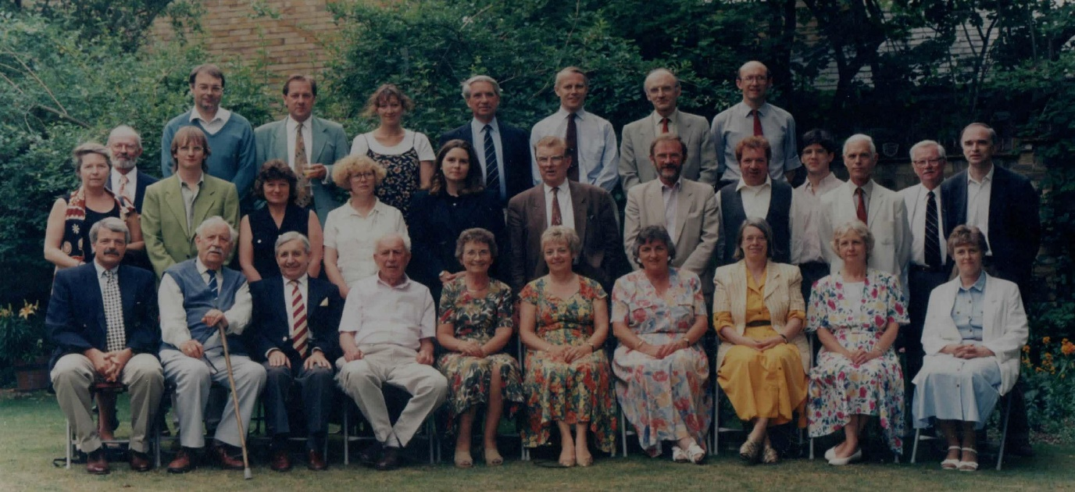
1996 (pictured above)

The emergent focus of Land Economy
The study of Land Economy has come a very long way from its origins in Estate Management in the School of Agriculture. Indeed, a great deal has changed since the invention of Land Economy in the 1960s. In a discipline that is essentially only practiced in Cambridge, the character and scope of the subject is defined by the work that is conducted within the Department, by the teaching and research undertaken by the combination of staff who are present in the Department at any particular time. But the development of the subject over the past fifty years can to some extent be characterised through the focus taken by successive Professors of Land Economy. The first vision was very much the brainchild of Donald Denman, drawing on aspects of surveying, law and economics but interpreted in his own particular way. While innovative and influential, it failed to connect with the wider disciplines and ran the risk of Land Economy becoming an isolated and potentially obscure field on its own. On Donald Denman’s retirement and the appointment of Gordon Cameron to the Professorship, the emphasis shifted firmly towards a more conventional approach in urban and regional economics. At that time, government funding cuts, particularly the closure of the Centre for Environmental Studies in London, brought a number of economists to Land Economy adding a significant and major thread to the discipline. Malcolm Grant’s introduction to the Department as Professor of Land Economy, with his expertise in planning and environmental law consolidated and expanded an emerging interest in environmental law and economics.
Through the 1990s, the research in the Department was almost wholly directed towards policy analysis: urban and regional, housing, environmental and rural. It was suggested at this time, that the Department might be better characterised as a School of Public Policy rather than a Department of Land Economy, especially at a time when student numbers were at a low ebb. But nevertheless, especially through its undergraduate teaching, the Department has maintained its links with the Royal Institution of Chartered Surveyors and the property profession. Its graduates have continued to achieve considerable success across all aspects of the sector. The focus on property within the Department developed beyond the traditional practice of surveying with the introductions of finance and business law into the curriculum in the 1990s, anticipating the subsequent move in the profession towards a greater openness to methodologies and practice in related disciplines. The establishment of the Professorship of Real Estate Finance in particular completed the reconnection back into contemporary property practice and research.
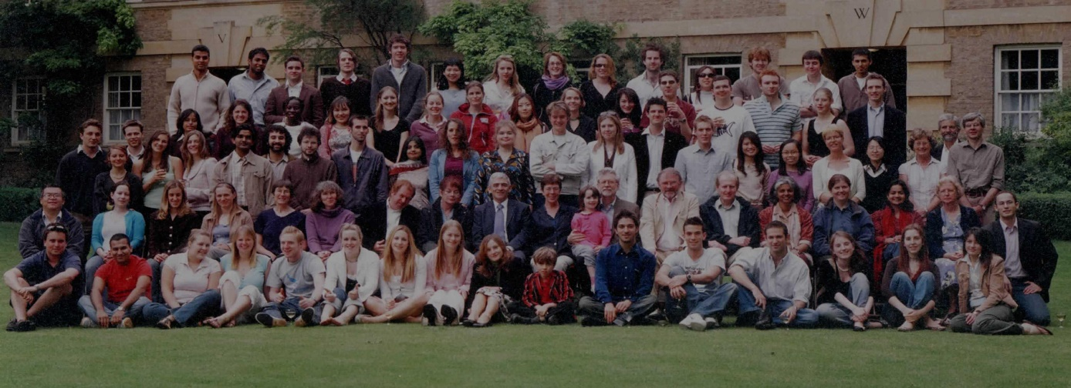
2005 (pictured above)
Thus, over the years, a number of new themes have been introduced into the study of Land Economy, reflecting emerging contemporary pressures and developments in related disciplines. This gives Land Economy enormous reach into areas of society’s greatest challenges, such as climate change, urban planning and regeneration, the provision of housing or conservation of biodiversity. And yet it still retains a coherence and consistency with Donald Denman’s vision. The core focus remains on the application of economics, law and planning for the analysis of the governance of land, real estate and the environment. The approach is directed towards the resolution of contemporary problems as well as to more fundamental analysis from both private and public sector perspectives. This includes both the role of governments in establishing regulatory frameworks within which land and related markets operate and the role of private organisations in owning, managing and developing physical and financial assets within those market contexts. There is considerable interaction between these two areas. Policy makers need to understand the ways in which markets operate, while private decision-makers need to understand and respond to policy practice and development. This combination gives the Department of Land Economy a unique and valuable perspective in addressing critical contemporary issues and places it well to respond to new issues and challenges in the future.

[1] Reporter 3 Oct 1919
[2] Reporter 21 October 1919
[3] £24,000 in 2012 prices
[4] Braybrook Smith had previously held posts as Vice-Principal at Wye College, University of London, and Secretary of Agriculture for the Union of South Africa. (Stewart Richards, The Agricultural History Review Vol. 36, No. 2 (1988), pp. 172-187)
[5] £1,470 in 2011 prices
[6] Paper on the ‘Establishment of a Development Fund’ (undated)
[7] Denman, Donald (1993) A Half and Half Affair: Chronicles of a Hybrid Don. Churchill Press Ltd, London, pp124-8.
[8] Harold Samuel, subsequently Baron Samuel of Wych Cross, started his career as an estate agent in London but then turned to property development and investment. In 1944 he acquired shares in the Land Securities Investment Trust, which owned three properties with total assets of under £20,000. In 1947 a decision was made to concentrate on commercial property in and around the West End with immediate success. In March 1948 the Investors’ Chronicle described the growth of The Land Securities Investment Trust as ‘meteoric’ and in 1950 the Evening Standard commented that the value of the shares approached a level where Harold Samuel would become ‘the first post war millionaire’. Land Securities was subsequently to become the largest property company in the UK. Harold Samuel donated to many charities, and was elected to an honorary fellowship of Magdalene College in 1961, knighted in 1963 for public and charitable services, and became a life peer in 1972. (Oxford Dictionary of National Biography and Land Securities website).
[9] Half and Half Affair, p129.
[10] Letter to the Vice-Chancellor from the Master of Peterhouse, 13 December, 1955.
[11] Reporter 25 January 1961.
[12] Memorandum from the Board of Estate Management included in report from the Council of the Senate. Reporter 25 January, 1961.
[13] Reporter 31 January 1961
[14] Reporter 28 February 1962.
[15] Half and Half Affair, pp153-157.

